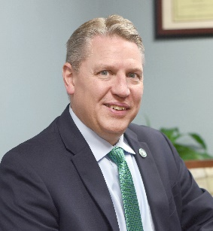
T. Hampton Hopkins, EdD

HamptonHopkins.com
704-614-2785
Hampton@HamptonHopkins.com

Professional Profile
- Successful leader with 30+ years as an educator, international speaker, and consultant
- Significant experience in higher education, corporate project planning, and non-profit leadership
- Effective motivational leader with experience in top-level strategic initiatives and establishing corporate vision
- High-energy communicator, teacher, and facilitator
- Strong commitment to quality and customer service

Areas of Expertise
- Leadership and Board Development
- Diversity, Equity, and Inclusion
- Ethics and Integrity
- Communication and Teambuilding
- Change Management and Conflict Resolution

Professional Experience
- President, Baptist Health Sciences University
- Past President, Carolinas College of Health Sciences
- Faculty Member, City University of Seattle and National University

Professional Recognition
- Senior Fellow, American Leadership Forum (Charlotte)
- President’s Excellence in Teaching Award, City University of Seattle
- Certified Instructor, Phi Theta Kappa Leadership Development Program
- Certified Trainer, National Coalition Building Institute (NCBI)

Selected Endorsements
- Thank you for your excellent presentation. You certainly had an engaging manner that made it inviting for many to ask questions or make comments.
- I believe the physician shareholders were very satisfied with the retreat and consider it time well spent. You certainly contributed significantly to this…
- Thought-provoking and eye-opening. Inspired me to have more clear-cut goals for becoming the man I want to be.
- Dr. Hopkins made the learning experience fun and engaging.
- He really made me think.
- He was cool.

